Passive Vocabulary

💤 What is Passive Vocabulary
# Source: Chatgpt (GPT-4-turbo) at [7/30/2025]
Passive vocabulary refers to the words you recognize and understand, especially in reading or listening, but do not use actively in everyday speech or writing.
🟨 It's often used interchangeably with receptive vocabulary, though some educators use passive to emphasize non-use, even if the word is understood well.

✅ Key Features:
# Source: Chatgpt (GPT-4-turbo) at [7/30/2025]
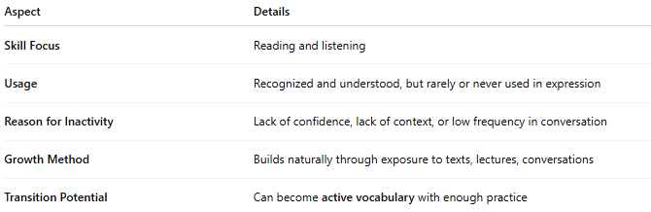
Aspect | Details
Skill Focus | Reading and listening
Usage | Recognized and understood, but rarely or never used in expression
Reason for Inactivity | Lack of confidence, lack of context, or low frequency in conversation
Growth Method | Builds naturally through exposure to texts, lectures, conversations
Transition Potential | Can become active vocabulary with enough practice

🧠 Example:
# Source: Chatgpt (GPT-4-turbo) at [7/30/2025]
- You understand the word “obsolete” while reading an article
👉 But you never say or write it in daily life

👤 Who Has Passive Vocabulary?
# Source: Chatgpt (GPT-4-turbo) at [7/30/2025]
- Everyone, but especially:
  - Language learners who understand more than they can say
  - Native speakers who read widely but use a simpler active vocabulary
  - Children or students growing in language ability

🔄 Passive vs Active Vocabulary
# Source: Chatgpt (GPT-4-turbo) at [7/30/2025]
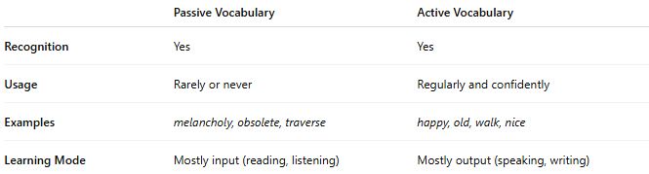

 | Passive Vocabulary | Active Vocabulary
Recognition | Yes | Yes
Usage | Rarely or never | Regularly and confidently
Examples | melancholy, obsolete, traverse | happy, old, walk, nice
Learning Mode | Mostly input (reading, listening) | Mostly output (speaking, writing)

Passive Vocabulary vs Receptive Vocabulary
# Source: Chatgpt (GPT-4-turbo) at [7/30/2025]
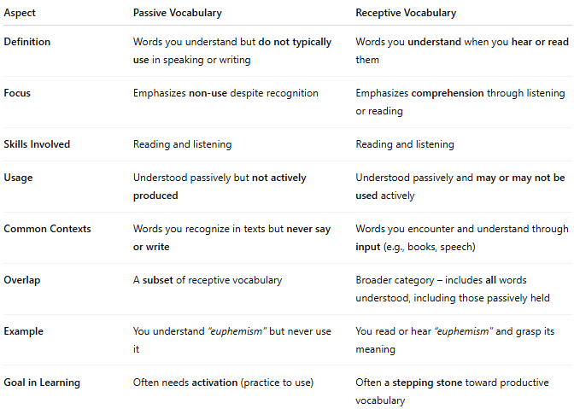

Aspect | Passive Vocabulary | Receptive Vocabulary
Definition | Words you understand but do not typically use in speaking or writing | Words you understand when you hear or read them
Focus | Emphasizes non-use despite recognition | Emphasizes comprehension through listening or reading
Skills Involved | Reading and listening | Reading and listening
Usage | Understood passively but not actively produced | Understood passively and may or may not be used actively
Common Contexts | Words you recognize in texts but never say or write | Words you encounter and understand through input (e.g., books, speech)
Overlap | A subset of receptive vocabulary | Broader category – includes all words understood, including those passively held
Example | You understand “euphemism” but never use it | You read or hear “euphemism” and grasp its meaning
Goal in Learning | Often needs activation (practice to use) | Often a stepping stone toward productive vocabulary

✅ Summary
- Receptive vocabulary includes everything you understand, whether or not you use it.
- Passive vocabulary refers to words within your receptive vocabulary that are not used by you in speech or writing.
🔄 All passive vocabulary is receptive, but not all receptive vocabulary is passive.

